The Challenge (careers.quintiq.com/puzzle.html)

The bus-driver-planning challenge

You work in the planning department at Big Blue Buses. Every day, for not much money and no glory at all, you take on the challenge of creating an optimum working schedule for Big Blue Buses’ drivers to cover the next 14 days.

The closer your schedule is to optimum, the happier your boss and the drivers will be. A low score means an angry boss and angry drivers.

If you’re interested to be a part of Quintiq, then take up this challenge and show us your skills. Score 85% or above and we guarantee you an interview with our exciting organization.

Earn your wage

It’s a real puzzle, and it looks something like this:

* There are three bus lines: Line 1, Line 2, Line 3
* You must allocate two drivers per line per day. One for the morning shift and one for the late shift.
* A driver can only do one shift per day; early or late.
* There are eleven bus drivers: A, B, C, D, E, F, G, H, I, J, and K. Some are only qualified to drive on Line 1, 2 or 3, while some are qualified to drive on a combination of two of those lines. Find the qualifications under each driver name in the Shift Planning form.
* Every driver is entitled to days off. Days off are indicated with dark gray nodes in the Shift Planning form. You can’t assign shifts on days off.
* Some drivers prefer to take particular days of the week off. This is indicated by light gray nodes in the Shift Planning form. These are preferences, rather than rules.
* Drivers may prefer to work an early or late shift on particular days. The yellow nodes in Shift Planning form indicate shift preferences.
* Most drivers dislike working too many late shifts. Therefore, the late shifts should be distributed as fairly as possible among the drivers. You should aim to assign exactly 4 late shifts to each driver over the two-week planning period.
* According to an agreement with the Transport Workers Union, a driver must not be assigned a late shift followed by an early shift the next day.
* According to a second agreement with the Transport Workers Union, a driver can only work no more than three consecutive late shifts.

**You can earn and lose points in the following way:**

|  |  |
| --- | --- |
| Respect a single shift preference | **+3** |
| Respect a single driver day-off preference | **+4** |
| For each allocated long rest (3 or more consecutive days off) | **+5** |
| For each unassigned shift | **-20** |
| For each late shift followed immediately by an early shift in a single driver’s schedule | **-30** |
| For every after the third consecutive late shift assigned to a single driver | **-10** |
| For every late shift assigned that is not equal to 4 | **-8** |

How to Play

The bus-driver-planning challenge

* You have 1 hour to solve the puzzle.
* Planning a shift on a particular driver can be done in 2 mouse clicks:   
  1. Click on the shift in the shift bank (at the top of the application) and   
  2. Click on the day on which you want to plan the shift.

**To plan a shift:**

1. Click on the shift you want to plan in the shift bank (on the top part of the application). The system highlights the qualified drivers for the shift (indicated by green rectangles on the driver grid)
2. Click on one of the qualified drivers (one of the green rectangles) to plan the shift

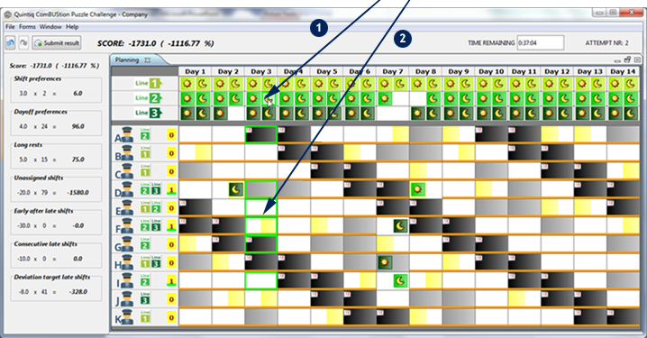

* Moving a shift from one driver to another is also done in 2 mouse clicks:   
  1. click on the shift you want to replan and   
  2. click on the grid of another driver on which you want to replan the shift

**To replan a shift on another driver:**

1. Click on the shift you want to replan. The system highlights the qualified drivers for the shift (indicated by green rectangles on the driver grid)
2. Click on one of the qualified drivers (one of the green rectangles) to replan the shift. Replanning a shift on the day that already has a shift assigned will swap the 2 shifts.

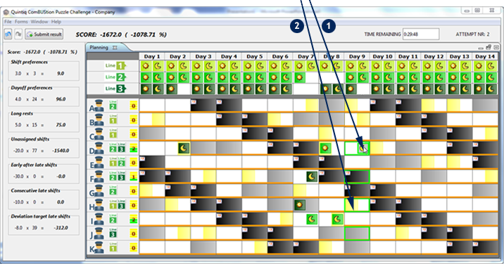

* Unplanning a shift can be done by clicking on the shift and selecting Unplan from the context menu or pressing the Del button on your keyboard.
* Press the Submit result button on the application toolbar to submit your result and end the puzzle. This Submit result process will happen automatically when the time is up.

